**Find list of Number divisible by 2 using Lambda and filter()# Input as list of numbers**

**# Result is list of number divisible by 2**

**ls =[12,17,34,23, 56,89,23,45,67,89,67,2312,45,99]**

**# Filter takes two parameter lambda and List**

**print( filter(lambda x : (x%2 == 0), ls))**

**print(list(filter(lambda x : (x%2 == 0), ls)))**

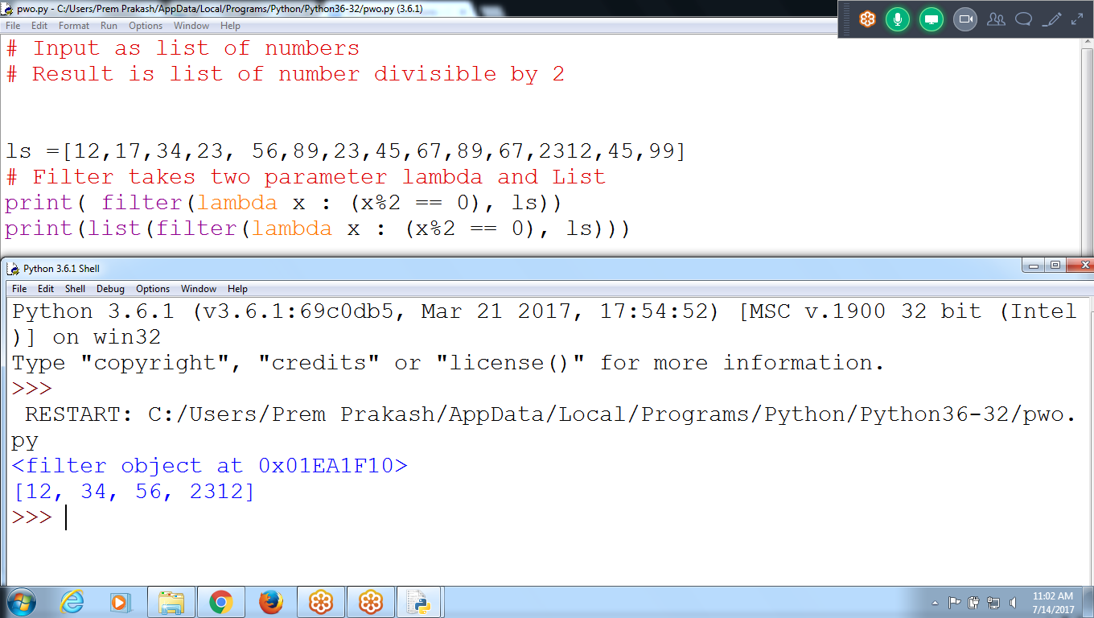

**(or)**

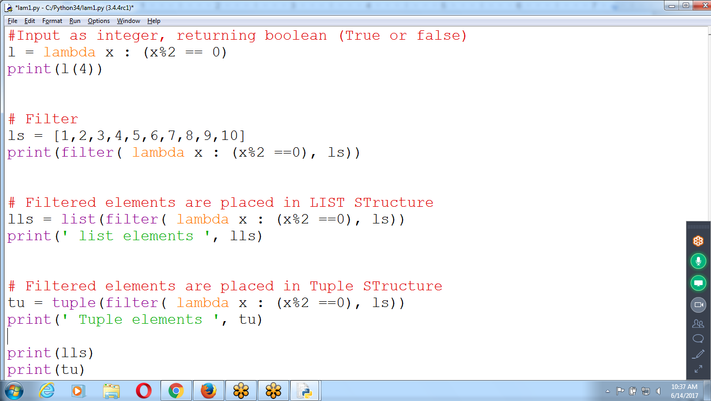

**#Input as integer, returning boolean (True or false)**

**# Result : True or false**

**l = lambda x : (x%2 == 0)**

**print(l(4))**

**# Filter**

**# Result : Filtering displaying Memory Address**

**ls = [1,2,3,4,5,6,7,8,9,10]**

**print(filter( lambda x : (x%2 ==0), ls))**

**# Filtered elements are placed in LIST STructure**

**# Result : Filtering and Arranging in List TYPE**

**lls = list(filter( lambda x : (x%2 ==0), ls))**

**print(' list elements ', lls)**

**# Filtered elements are placed in Tuple STructure**

**tu = tuple(filter( lambda x : (x%2 ==0), ls))**

**print(' Tuple elements ', tu)**

**print(lls)**

**print(tu)**

**# List can modify Structure**

**lls.append(12)**

**print(lls)**

**# TUple can NOT Modify structure**

**#tu.append(12)**

**Using Normal Function and Lambda function**

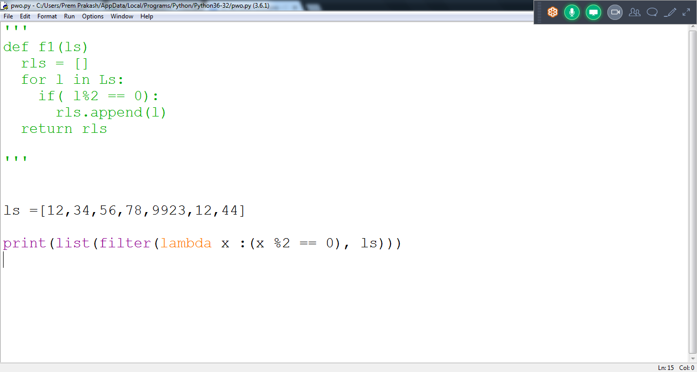

**Example :List contains element of type LAMBDA**

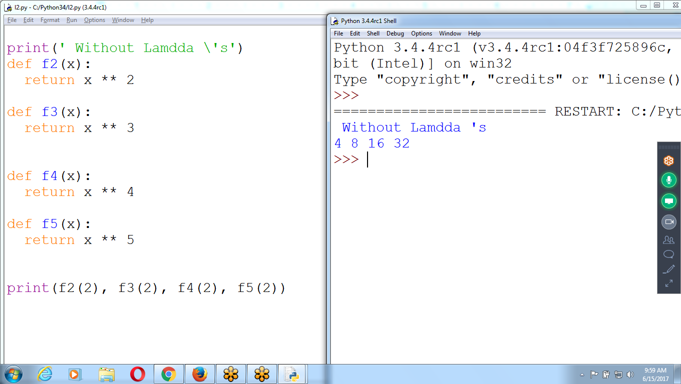

**#Without Lambda's find power of 2,3,4,5 need to write multiple functions**

**print(' Without Lambda \'s')**

**def f2(x):**

**return x ** 2**

**def f3(x):**

**return x ** 3**

**def f4(x):**

**return x ** 4**

**def f5(x):**

**return x ** 5**

**print(f2(2), f3(2), f4(2), f5(2))**

**Without Lambda find Square, cube**

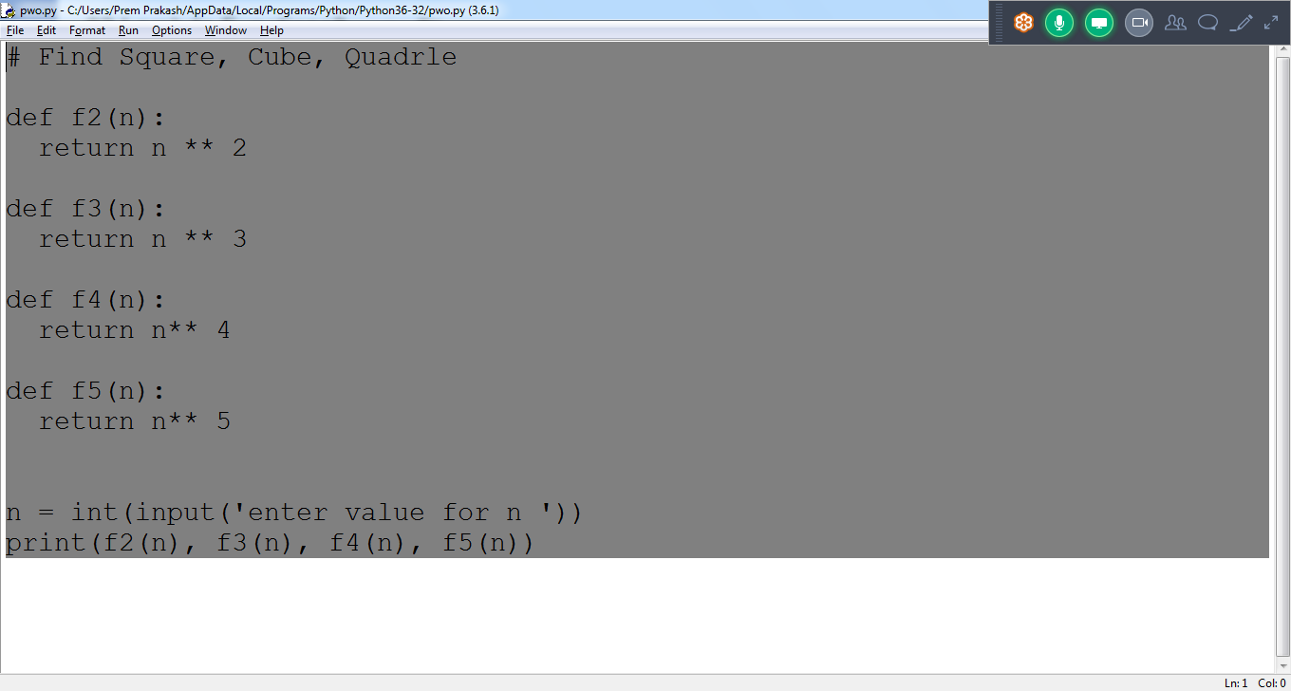

**List of Lambdas**

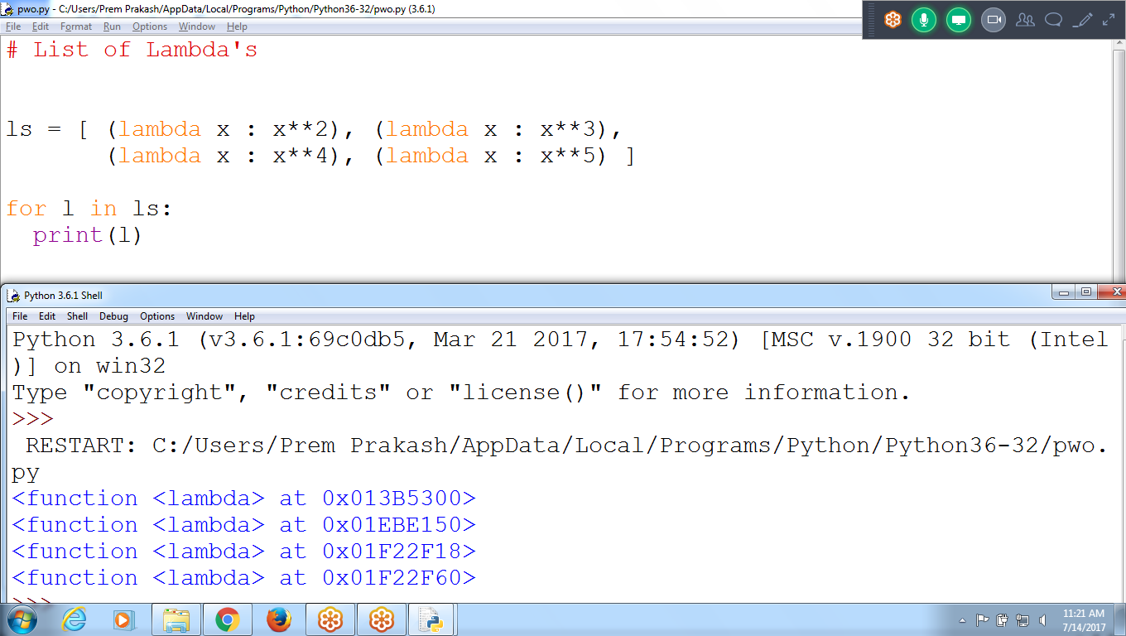

**Passing parameter to Lambda Functions in List**

**# List of Lambda's**

**ls = [ (lambda x : x**2), (lambda x : x**3),**

**(lambda x : x**4), (lambda x : x**5) ]**

**for l in ls:**

**print(l(7))**

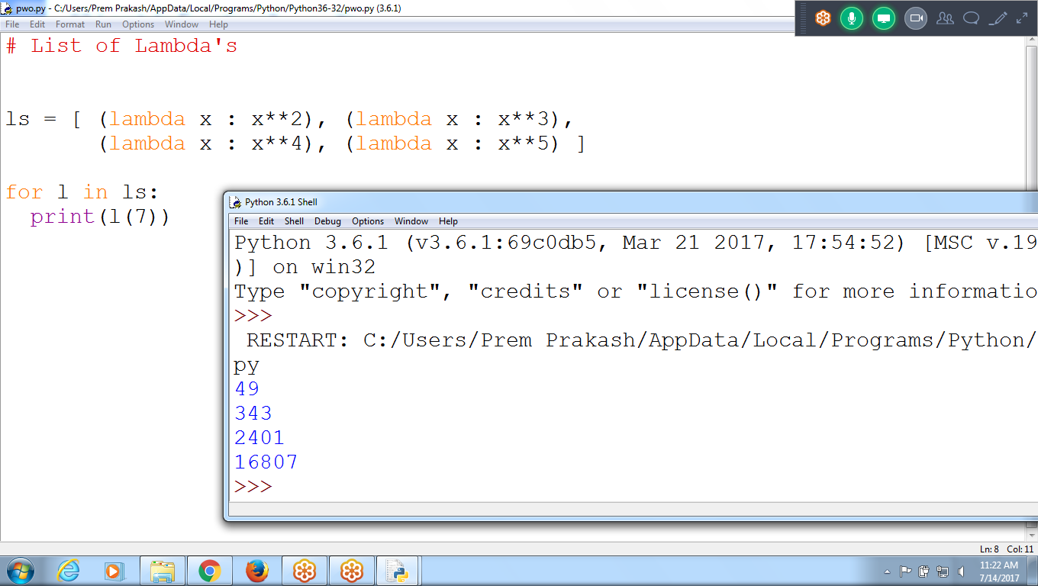

**Find List of Elements, multiples of 2 in range of 1 to 100**

**range()**

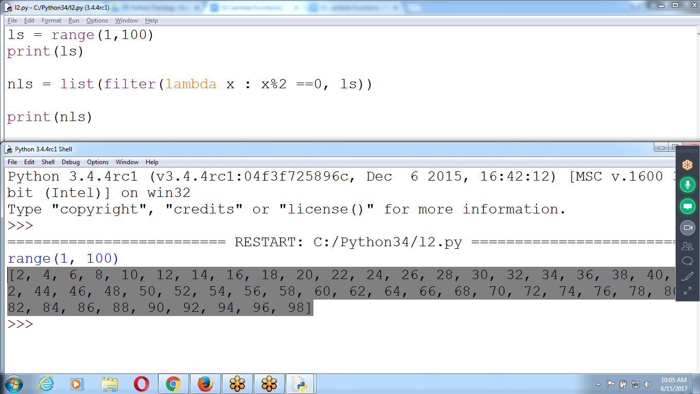

ls = range(1,100)

nls = list(filter(lambda x: (x%2 ==0),ls)) # Returning Filter object

print(nls)

for i in range(1,100):

print(i)

print(i*10)

**COllecting lambda values in LIST**

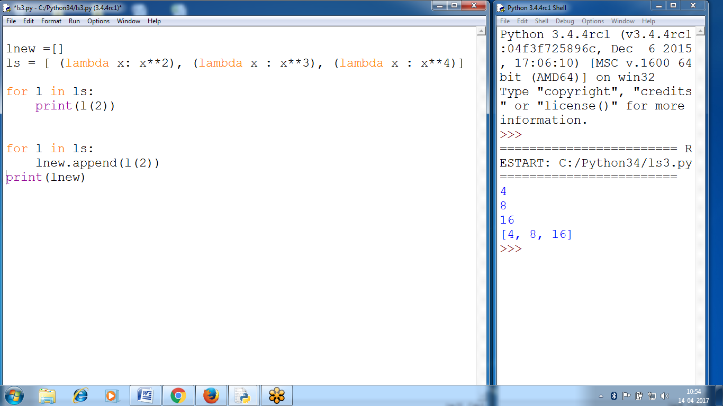

lnew =[]

ls = [ (lambda x: x**2), (lambda x : x**3), (lambda x : x**4)] # list of lambdas

for l in ls:

print(l(2))

for l in ls:

lnew.append(l(2))

print(lnew)

**Enumurate**

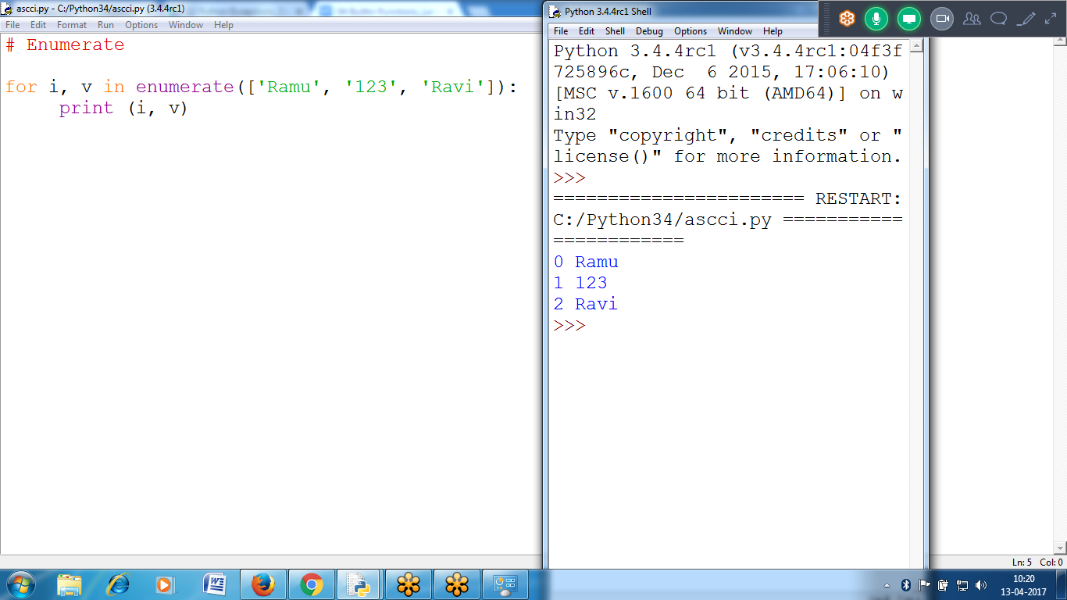

# Enumerate

for i, v in enumerate(['Ramu', '123', 'Ravi']):

print (i, v)

Using Dictionary in Enumerate

